**Sudoku’nun Konusu:** Aşağıdaki uyarılara göre boş hücreleri 1 ve 9 arasındaki rakamlarla doldurmaktır.(Her hücre için en az 1 rakam):

**Sudoku Rules:**

Sudoku, starts with some grid cells filled with numbers;

* The number can only occur once per line.

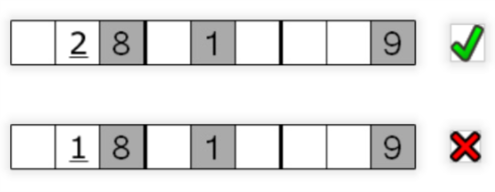

* The number can only be once on each column.

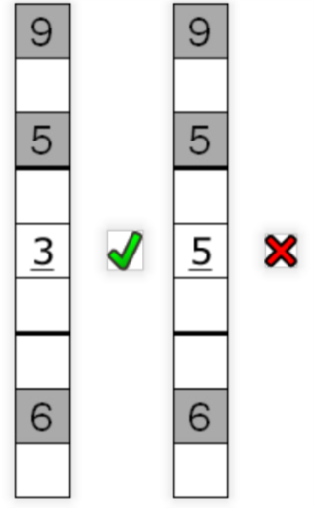

4.The round can only be once on each territory.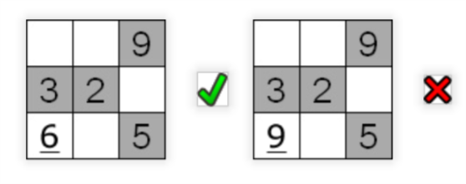

These rules can be summarized in that each count can be used only once in each row, column and region.